Mount Litera Zee School, Haridwar
Syllabus Term-II (2016-17)
Class-VI
SA 2

Subject | Syllabus
ENGLISH | Gulmohar-Ch-8 Resting Hill Ch- 9 The Mask, Ch-10 Brighter Still, Ch-11 Saving the tiger, Ch- 12 The Canterville Ghost Poem: Vocation, Cows on the beach, The fog  Enjoying Grammar: Ch-14,15,16,17 , 18, 19, 20, 21, 22, 23.  Writing Skill: Imaginative essays, Letter of apology, Paragraph writing.
HINDI | 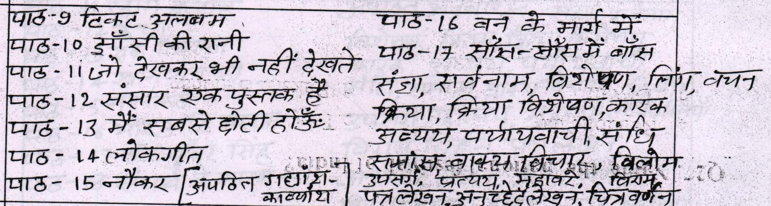
Maths | Fractions , Decimal , Playing with numbers , Practical Geometry , Data Handling , Mensuration.
SCIENCE | L-5 Sorting materials into groups , L-6 Changes around us , L-8 Getting to know about plants ,L-10 Habitat of the living , L-12 Fun with magnets , L-14 Electricity and circuits, L-17 Garbage in, Garbage out
S.ST | His. - Lesson 10 Flowering of religion and commerce, L-11 India from the 4th century to 7th century . Geo- L-19 Major relief features of the world L-20 India Physical features,L-21 India's climate, L-22 Natural vegetation and wild life . Sand P life L-27 Panchayati Raaj L-28 Rural Administration ,L-30 Livelihood
SANSKRIT | 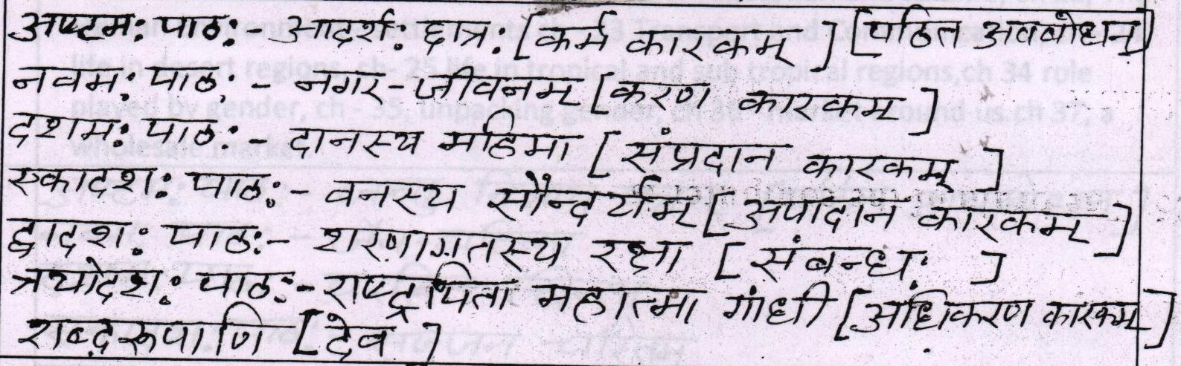
COMPUTERS | Ch-7 More about MS Excel 2007 , Ch-8 Introduction to QBASIC , ch-9 QBASIC Statements Ch-10 QBASIC- Programming Statement 1 , Ch-12 Introduction to Email
G.K | Unit - 4 - The world of nature, unit - 5 Sports and games unit - 6 Art and culture,Current affairs

